Job Aid for Session Entry into the TRB Poster Session System for

AASHTO RAC High Value Research and Supplemental Award Winners

Each year, the AASHTO Research Advisory Committee (RAC) chooses four High Value Research (HVR) and Supplemental awards, which are showcased at a TRB poster session. This job aid only covers how to enter the poster session information into TRB’s Event System. For further information on the HVR nomination and selection processes, please see the AASHTO RAC Value of Research Task Force document library on the RAC website.

Since HVR is an AASHTO RAC Value of Research (VOR) Task Force process, a TRB committee must sponsor the poster session; therefore, the TRB Standing Committee on Research Innovation Implementation Management (RIIM—AJE35) does this. The deadline to get the information into TRB’s Event Management System (EMS) is October 1 each year. VOR Co-Chairs and/or volunteers and AASHTO Region Chairs will gather the information during August and September. Once the information is gathered and the system opens for entry, the event entry person will do the following:

Overall Event Information Entry/Editing

- Ensure that you have access to the EMS. If you do not, the RIIM Chair and/or our TRB Staff Liaison (at the time of this writing: Emily Parkany and Claire Randall respectively) will be able to grant you access. The system will be found on trb.org, then click on MyTRB / Annual Meeting / Event Planning / Manage Events. You will likely need to get access every year.
- A list of AJE35 events created by the RIIM Chair should appear and will look like this:

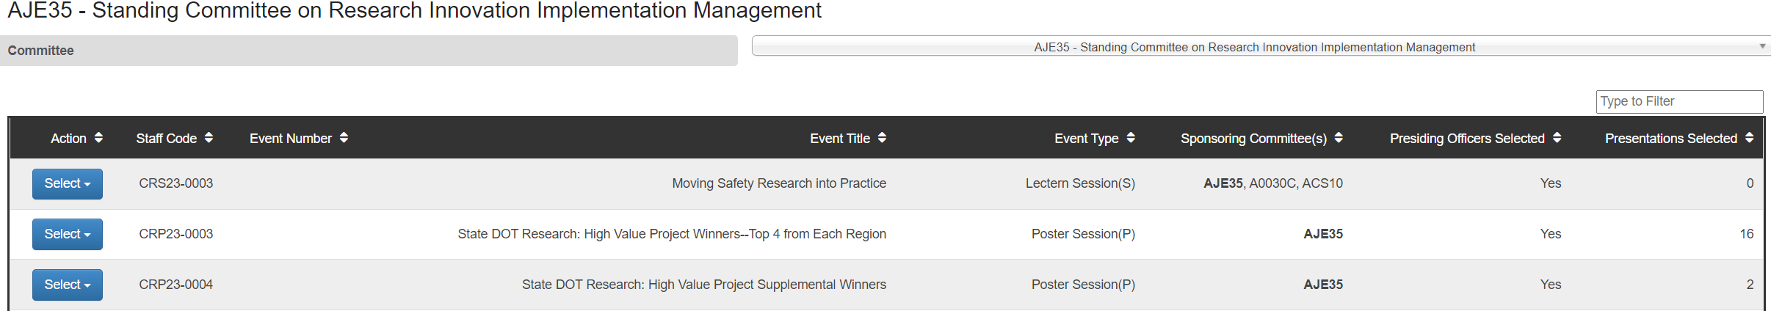

- Click on Select by the event you are editing (the State DOT event with “High Value Research” and “Supplemental Winners” in the titles), then click Edit Event.
- You can then edit the event title and information, then choose AJE35 as the Primary Sponsoring Committee. If other committees are co-sponsoring, you can choose them from a list below.
- Choose Subject areas under Available Subjects. Research and Transportation-General are good ones since these poster sessions cover a wide variety of topic areas.
- Click Add Presiding Officers and complete their information.
- Click Save and Continue. Do this often so you won’t lose your work. Anything entered here can be edited until 10/1.

The overall session entry information will be put into the TRB mobile app program. The individual posters will not; however, they can be located using the on-line website search of the meeting events.

Entry of Individual Poster Information

Once you have the main events entered, you can add the individual poster information following these steps:
- Click Add Presentation.
- A list of invited presentations will appear; however, you will click on Create a New Presentation.
- A screen will appear for you to enter the Title and type or copy/paste an Abstract
- Select AJE35 as the Assigned Committee (it should be the only choice).
- Click Add Presenter. The following screen should appear:
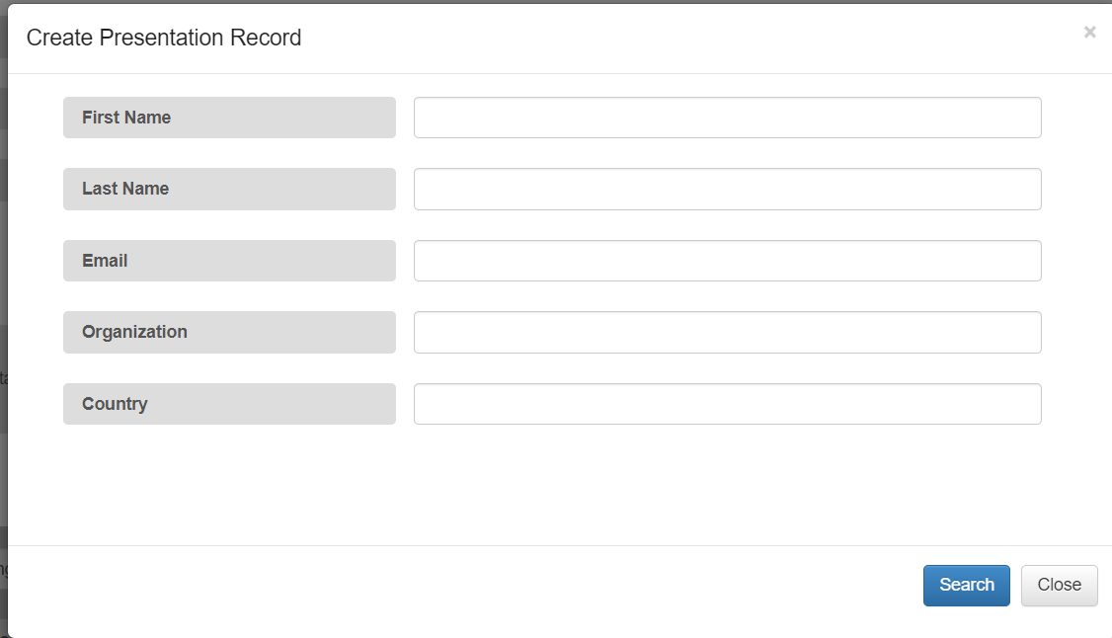

- Most people presenting will already have a MyTRB account. Please type the presenter’s email address. You can also type their first and last names if you wish.
- Choose the country (should be USA in presenters of this poster session), then click Search.
- If the person has a MyTRB account, their name should appear in a search record:
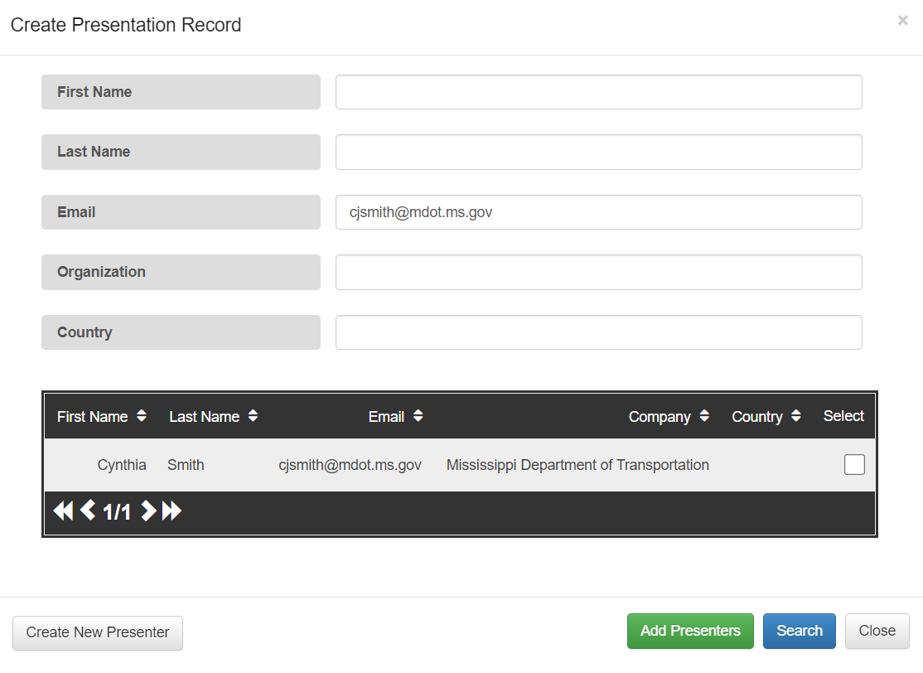
- If the person appears in the search results and is correct, click Select.
- If the person does not appear, you will need see a screen with no search results. You will need to click Create New Presenter and enter their information.
- Do this until all posters are entered into both sessions (HVR and Supplemental).

Please contact the VOR Co-Chairs and/or the RIIM Chair if you have questions or issues.

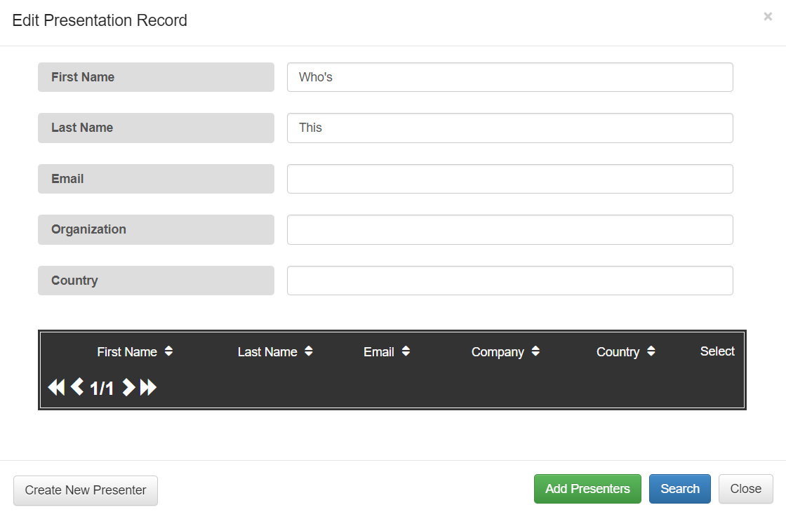

- Once you enter the new presenter information and/or the search yielded someone who already has a MyTRB account and is correct, click Create.
- If you need to add another presenter, click Add Presenters and repeat the process and click Create.
- You should then be able to see the new Presentation record in the overall session information.
- Click Save and Continue or you might lose your work.

There is a Printable View, which can be accessed by pressing Select beside the relevant event on the main Committee event page, then selecting Printable View. This is useful to share information with others who do not have access to the system.

