High Value Research Projects Submittal and Selection Guidance
AASHTO Research Advisory Committee (RAC) Value of Research Task Force

Overview –This document combines the High Value Research process submittal and selection processes.

Acting on the strategic plan of the AASHTO Special Committee on Research and Innovation (R&I), the AASHTO Research Advisory Committee (RAC) asks states each year to identify and document recently completed “high‐value” research (HVR) projects.

The RAC Value of Research (VOR) Task Force oversees the submission process and works with the state DOTs and the 4 AASHTO regions to select the following:

- High Value Research awards--The top 4 from each region, 16 in all
- Supplemental Research awards—Two projects for each of two subject areas are chosen from each region:
  - One area is always Safety.
  - The other area each year, generally the most common study code for that year (examples: Maintenance and Preservation, Education and Training, Pedestrians and Bicycles, and many more). There will be more explanation on these further in the document.

Every January, the VOR Task Force Chairs announce the solicitation notice to RAC for HVR projects. The selected projects are then featured in AASHTO events, in the RAC virtual exhibit hall, and are also showcased at a poster session at the Transportation Research Board (TRB) Annual Meeting.

The VOR Task Force has put together this guidance document to assist AASHTO RAC Research Managers and staff in the submittal and selection of HVR projects from their state. Each state is encouraged to submit as many HVR projects as appropriate and that meet the specified criteria. The goal is for each state to contribute at least one HVR project each year. This guidance document also outlines the criteria that should be used for the state’s selection of HVR projects and clarifies how the High Value Research projects are selected.

HVR Submittal Timeline and Deadline
The HVR submittal timeline includes the solicitation, submission, and selection of HVR from January through May 15th (shown below). Submissions are accepted starting in mid-January (generally the Tuesday after the Dr. Martin Luther King, Jr., holiday) of each calendar year. States must submit projects through the High Value Research (HVR) website by 11:59 pm Eastern time on March 31 of a given year. Project submittals after this date will not be accepted. The VOR Chairs send out the HVR solicitation notice and coordinates with the RAC Regional Chairs on getting the HVR projects entered on the HVR website. The RAC Regional Chairs encourage all states within their region to submit HVR projects and participate in the voting process. The final list of the top 4 projects from each region is due by May 15th.

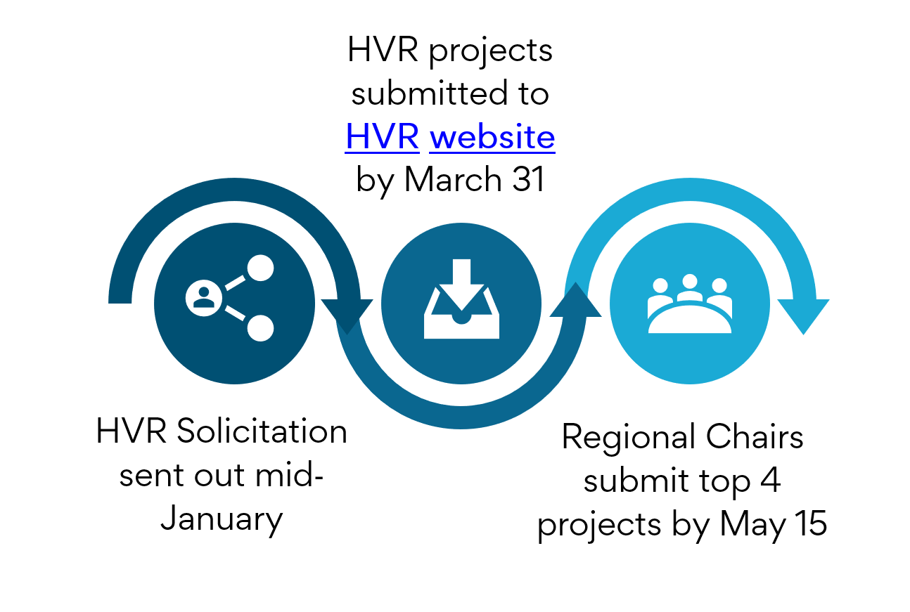

Role and Responsibilities
The submission and selection of the HVR projects relies on the following individuals/groups play parts in this process:
- Value of Research (VOR) Task Force
  - Co-Chairs assist state DOTs and regions, set deadlines, and announce winners.
  - Co-Chairs and other VOR volunteers help with:
    - Determining the second Supplemental area each year
    - Creating and mailing certificates
    - Working with winning agencies and/or PIs to get presentations and fact sheets prepared for the July RAC meeting and material for the HVR and Supplemental poster sessions at the January Transportation Research Board (TRB) Annual Meeting

General Guidance for HVR Submission
- Consider selecting research projects when the value or benefit of the research has been quantified or qualified.
  - Implementation of the research results will lead to defined benefits (quantified or qualified) for the sponsor agency that outweigh the cost of the research and implementation.
  - Project implementation has led to significant changes within agencies, positively impacting the conduct of business. The changes may also be adapted to other agencies across local, state or federal levels.
  - The state or other appropriate agencies are making demonstrated progress in implementing the results of the research or otherwise following the project recommendations.
- The project addresses a demonstrated need, answers specific questions or deals with documented problems relating to the state transportation agencies and its practices.
- The project clearly identified and fulfilled its objectives.
- The research results are technically valid and directly support the project recommendations.
- Research results and implementation activities display innovation. If a project is similar to parallel or past efforts, the nominee should note how the project promotes advancement beyond other results.
- Consider research projects that have supplemental information and supportive materials (technical summary, video, pictures, technical brief, benefits summary, etc.) to help support and tell the research story.
  - Relevant files can be uploaded as attachments to the HVR website.
  - Please be aware that you can only view your own attachments on the HVR website. You cannot view submittals or attachments from other states.

Minimum Criteria for Project Submittal and Qualifying Projects
States may submit any research project with the following qualifications:

- A state can submit any research project completed by March 31 having significant value or benefit to the department. Research projects that are still in‐progress should not be submitted. Research projects previously submitted which did not win a HVR award can be resubmitted.
- As implementation of results may take years, projects submitted should have been completed within the last five years.
- A state may submit completed research projects on which it served as the lead contracting agency, regardless of the funding source. This includes projects fully or partially funded through SPR, UTC, state, local or pooled funds or any other sources.
- States may combine multiple related or phased projects into a single entry, provided that at least one of the projects fits qualifications 1, 2 and 3 above.

States must nominate projects by March 31 of a given year. Review and voting for the High Value Research takes place from April 1 through April 30 and is conducted at a regional level. The High Value Research projects are identified by May 15 so that the states may make preparations to present projects and be recognized at the Summer RAC/TRB State Representatives Annual Meeting.

States may nominate any research project with the following qualifications:

- The project must be completed by March 31 of the year it is submitted. Projects that were submitted previously but did not win either a High Value Research or Supplemental award may be resubmitted provided all other criteria are met.

- A state may submit research projects on which it served as the lead contracting agency, regardless of the funding source. This includes projects fully or partially funded through SPR, UTC, state, local or pooled funds or any other sources.

- States may combine multiple related or phased projects into a single entry, provided that at least one of the projects fits both qualifications #1 and #2.

Criteria for submission and selection
States should submit projects and evaluate potential High Value Research projects based on the following criteria, in no specific order:

- The project addresses a demonstrated need, answers specific questions or deals with documented problems relating to the state transportation agencies and its practices.

- The project clearly identified and fulfilled its objectives.

- The research results are technically valid and directly support the project recommendations.

- The state or other appropriate agencies are making demonstrated progress in implementing the results of the research or otherwise following the project recommendations.

- Implementation of the research results will lead to defined benefits (quantified or qualified) for the sponsor agency that outweigh the cost of the research and implementation.

- Project implementation is leading to significant changes in agencies, positively impacting the conduct of business. The changes may also be adapted to other agencies across the local, state or federal levels.

- Research results and implementation activities display innovation. If a nominated project is similar to parallel or past efforts, the nominee should note how the project promotes advancement beyond other results.

- Region Chairs are in charge of the voting process for each region. This can be done by ranking or other agreed-upon means (example: each state ranks its top 4). Each state DOT gets to vote once, and a state DOT is strongly encouraged to vote for other DOTs’ projects and not their own.

- Once the 16 High Value Research Projects are chosen, the Supplemental awards will be from two areas:

  - Safety: This is a Supplemental category each year.
  - The most common study area based on study codes entered into the HVR website. Each submission is allowed up to 3 codes, so please select more than one if this applies. Once all submissions are in, VOR Co-Chairs and volunteers will determine this based on website data. Examples include but are not limited to:
    - Maintenance, Materials, and Pavements
    - Construction, Design, and Specifications
    - Bridges and Other Structures
    - Pedestrians and Bicycles
    - Education & Training
    - Data & Information Technology

Other considerations (submissions and ratings)
Aside from the selection/evaluation criteria, states should also take these factors into consideration when submitting or rating projects:

- Projects may address areas of expertise that are not common to all state DOT research managers. Research managers may have backgrounds in engineering, safety, planning, finance, public administration or other related fields. Project applications should be written for a broader audience beyond a technical practitioner level.

- Similarly, research managers should be careful not to be naturally biased when rating projects that fall into their own expertise. To help address this concern, research managers may want to seek the advice of others in their agency to review and rate projects.

- Projects may address topical or business areas that are not represented in all state DOTs. For example, only a portion of state DOTs handle motor vehicle functions, but some DOTs fund policy or safety-related research that relate to motor vehicle activities. Applications should underscore the impact of the research on the sponsoring agency, even if that business function is not common to other state DOTs. Evaluators should take this into account and review projects based on the merit to the sponsor agency, even if their own agency may not have an application for the research.

- Evaluators should understand the impacts of projects considering both breadth and depth. For example, one project may have a minor impact across a wide range of applications. Another project might have a major impact in a single or small set of applications. Either project may be considered to have high value.

