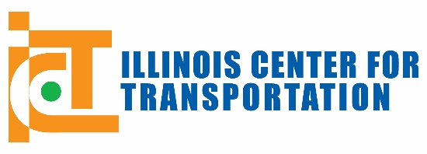
Request of Research Ideas – Due October 1, 2015

- Research Idea Title:

- Research Literature Review: Please describe the current state of knowledge and state of practice in this field, including studies underway in the TRID (http://trid.trb.org) and Research in Progress (http://rip.trb.org/search) databases, and how this relates to the research need. Limit: 1300 characters.

- Objective and Scope of the Proposed Research Idea: Clearly state the objective of the proposed research and briefly describe how the proposed work will address the research needs. Limit: 975 characters.

- Justifications for the Proposed Research: Please be specific as to how the research will benefit IDOT and the state of Illinois. Limit: 325 characters.

- Expected Implementation Outcome: Describe the expected quantitative outcomes in terms of policy advances, cost savings, increased life cycle, safety, environmental impacts and sustainability, user benefits, and/or other appropriate metrics. At minimum, explicitly list the benefits to IDOT regarding life-cycle cost and sustainability. Please note that IDOT is interested in immediate implementation of research outcomes. Limit: 650 characters.

- IDOT Sponsor: Please note that an endorsement by IDOT is strongly encouraged and will significantly increase the funding potential of this research idea. Attach e-mail or letter of support from an IDOT TAG sponsor listed below. (optional)

- Suggested review by the following Technical Advisory Group (TAG) or TAGs:
Construction
Environment
Pavement Design, Management & Materials
Planning
Public & Intermodal Transportation
Safety Engineering
Structures, Hydraulics & Geotechnical
Sustainability
Traffic Operations & Roadside Maintenance

- Estimated time to complete this project in months: (Please allow 6 months total for report preparation, review, and 3-month ICT editing process.)

- Total estimated funding for research: (This estimate must include the minimum 25% cost share required for all ICT projects) $

Submitter (Name): | Title:
Organization: | Phone #:
E-mail: | Mailing Address:

Please Note: Your research idea may be shared with others in an open Request for Proposal (RFP). IDOT and ICT reserve the right to select any researcher to carry out this research idea. Project start dates are selected by IDOT and ICT and typically coincide with the start of the semester.
Please e-mail this form to: DOT.BMPR.RESEARCH@illinois.gov. Questions may be directed to this e-mail address or call Megan Swanson at 217-782-3547.

