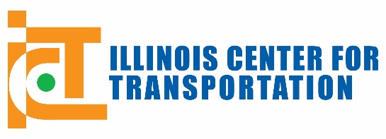

TRAVEL REQUEST FORM

Required for IDOT-Funded OUT-OF-STATE TRAVEL
and/or IN-STATE TRAVEL TO CONFERENCES*

ICT PROJECT NUMBER: R27-

PROJECT TITLE:

PRINCIPAL INVESTIGATOR (PI):

TECHNICAL REVIEW PANEL (TRP) CHAIR:

TYPE OF TRAVEL EXCEPTION REQUESTED (Check one):
Out-of-State Travel or In-State Conference

Traveler Name | Role | Estimated Cost
 |  | $
 |  | $
 |  | $

TOTAL ESTIMATED COST^: $

DATE(S) OF TRAVEL:

DESTINATION / CONFERENCE & SITE:

JUSTIFICATION (PURPOSE OF TRAVEL / PROJECT BENEFIT) (< 500 characters):

DATES OF SUBMISSION & APPROVAL / DISAPPROVAL:

Date Submitted to TRP Chair/BR for Approval (mm/dd/yyyy):

Approved by: TRP Chair or BR
(BR must approve if any IDOT employee is traveling, all other travel can be approved by TRP Chair)

Signature: ________________________________ Date (mm/dd/yyyy):

(Administration Purposes only) Travel charged to C-FOP # & Project #:

* If your specific out-of-state travel or travel to a conference was approved as part of the project workplan, please inform the TRP chair via e-mail when you travel and copy ictprojectmanagement@illinois.edu.
^Please purchase all airline tickets as early as possible to avoid high prices.

