Research Project Trading Card - Guidelines

Developed by the Connecticut Department of Transportation, Division of Research, as a method for communicating research results

The front of the card is developed in Adobe Photoshop. The back of the card is developed in Microsoft Publisher, but saved as a PDF file before sending it to the printer. Different printers have different file format requirements, so check with your printer before finalizing the documents.

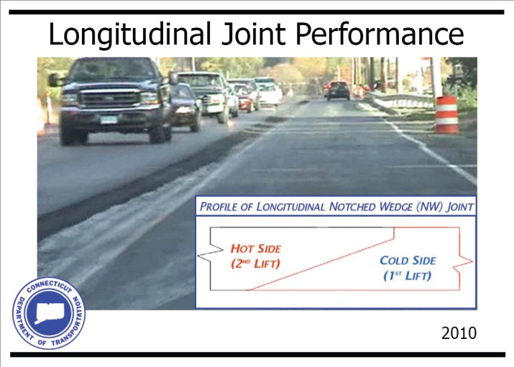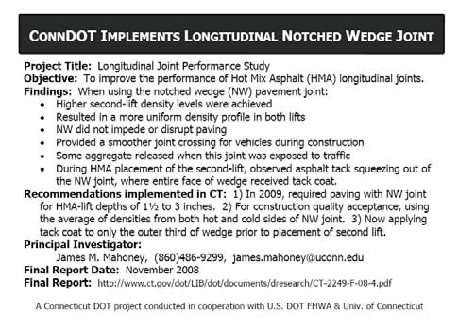

Size/Placement:
The baseball cardstock size is 3.5”x 2.5”; the color-image border size is 3.25”x 2.25”; and
the picture has maximum dimensions of 3”x 2”. Cards always use landscape page orientation.

Color:

The color of the border and title shape can be anything.
Double click on the layer and the Photoshop color palette appears. Choose the desired color.

Title Block:
The title block should be placed on the front of the card along the long edge of the card (at the top). Placement of the title elsewhere on the card is problematic when the cards are displayed a rack-style card holder.
In Photoshop, the basic shape can be chosen and then modified, using the Edit/ Transform
option.
The letter size and font can also be changed.

Organizational Symbol(s):
Symbol(s) can be moved to wherever it fits best with the picture. This applies to other logos and symbols that may be required to acknowledge research partnerships. The “In Progress” construction symbol should be added for projects that are not yet complete. Symbol size can be modified by using Edit/ Transform with the scale locked.

Picture:
To insert a picture, use File/ Open to select the picture desired. Once in Adobe Photoshop, select Image/ Image size and set your picture to maximum dimensions of 3”x 2”. Also the resolution must be set to 300 pixels/inch.
Then choose Select/ All and Edit/ Copy.
Then click on the baseball card file and select Edit/ Paste.

Back of Card:
The back is created in Microsoft Publisher in grayscale. The words should be written like stats are written for baseball cards. Diagrams or pictures can be inserted as well (if desired).

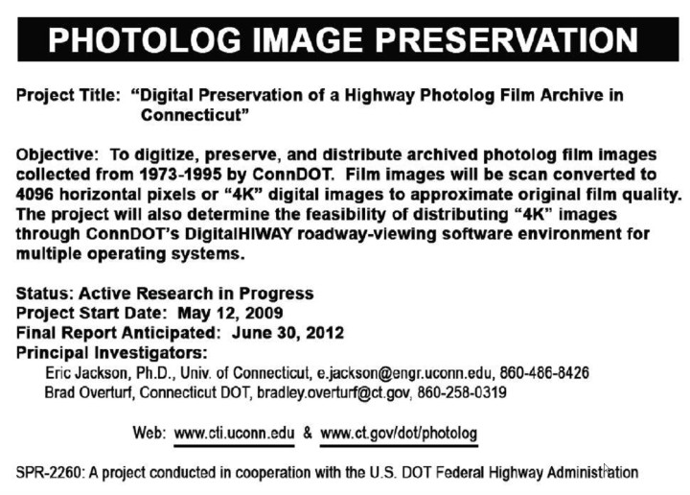Research Project Trading Card – Samples

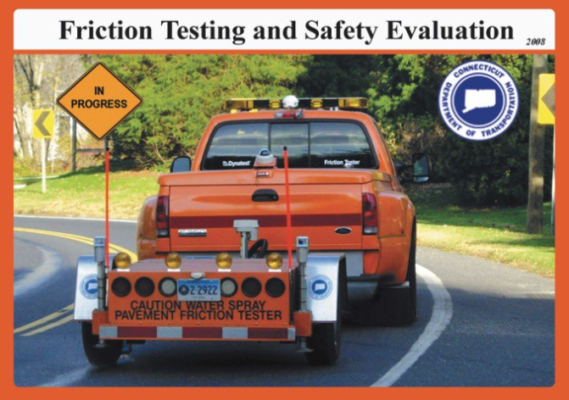  SPR-1417, “Friction Testing and Safety Evaluation Services” | 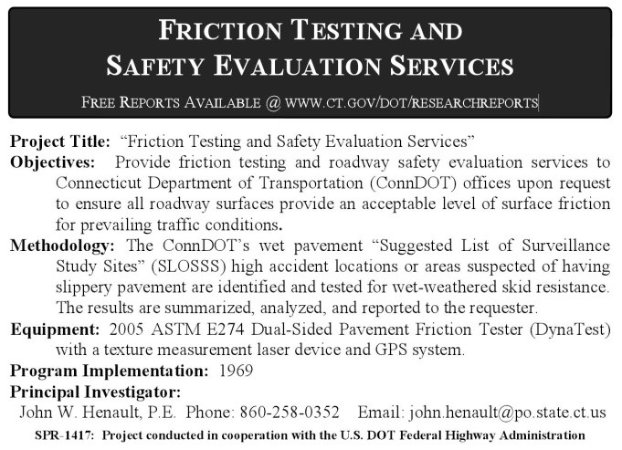  January 2008
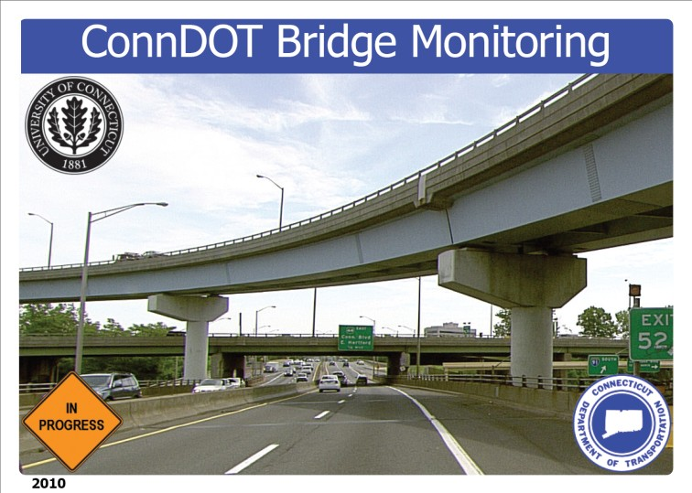  SPR-2217, “Monitoring of Highway Bridges in Connecticut” | 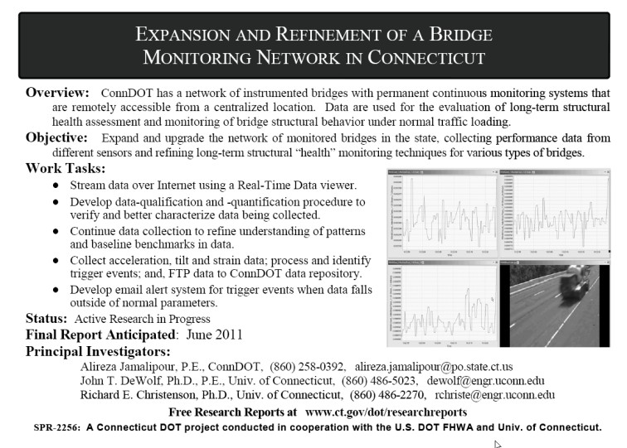  January 2010
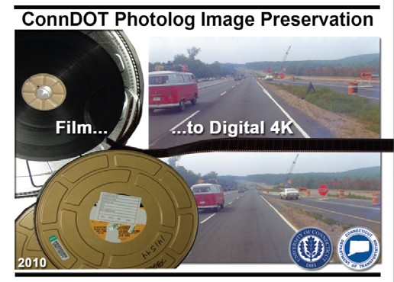  SPR-2260, “Digital Preservation of a Highway Photolog Film Archive in Connecticut” | January 2010

